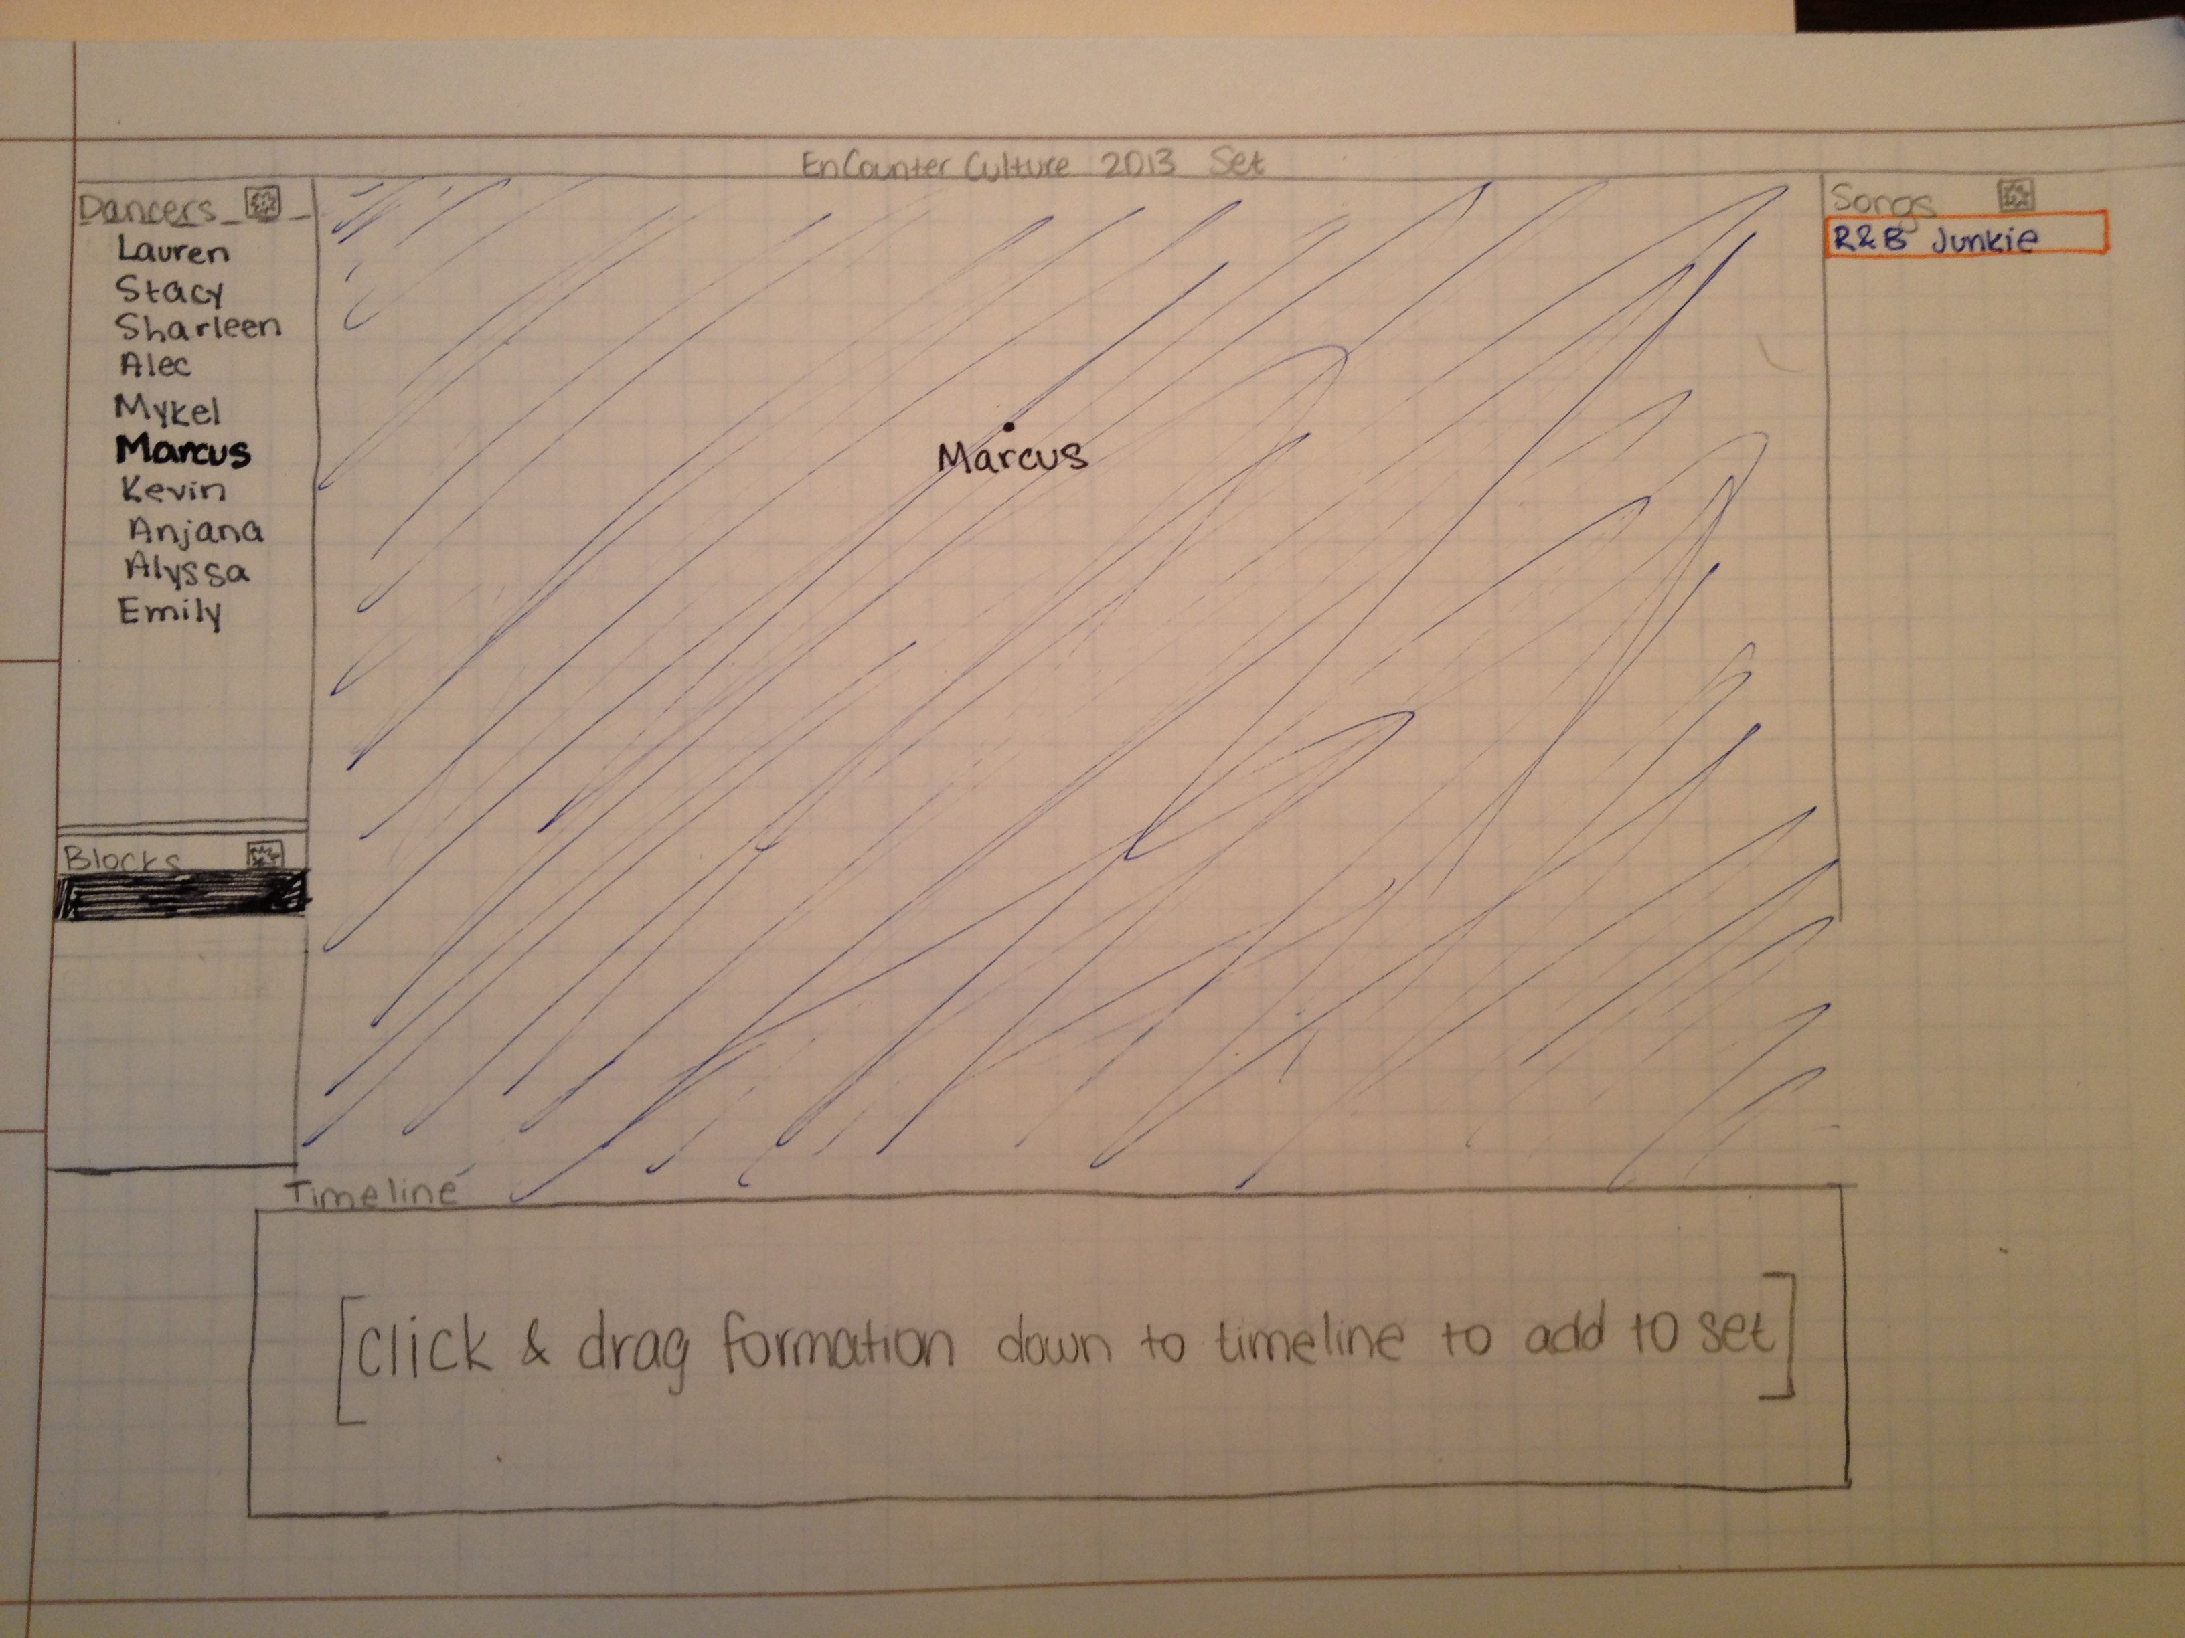

This is what the app would look like when you’re starting your first formation. You add the name of the song and then add the names of the dancers in that particular dance. You add a dancer by dragging his/her name to the canvas. When this happens, their name turns black and bold to indicate they are already in the formation. To save the formation, you would hold and drag the canvas down into the timeline. This layout was inspired by Final Cut Pro because they share similar user needs.

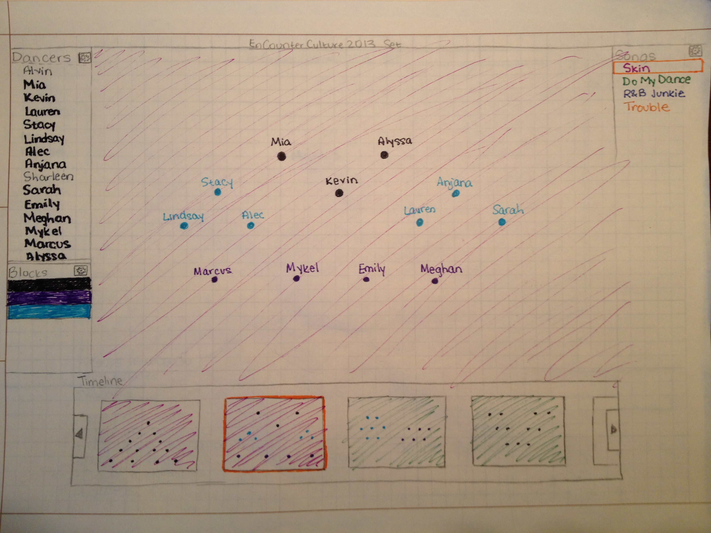

Once a set is more developed, it should look something like this. Each song has its own color, which is reflected in the background of the formations in the canvas and timeline. That way, the user knows which dance they are currently working in. User can add “blocks” to the formation which are represented by different coloration in the dots. The user sets this by clicking on a block color and then what dots should go in that certain block.

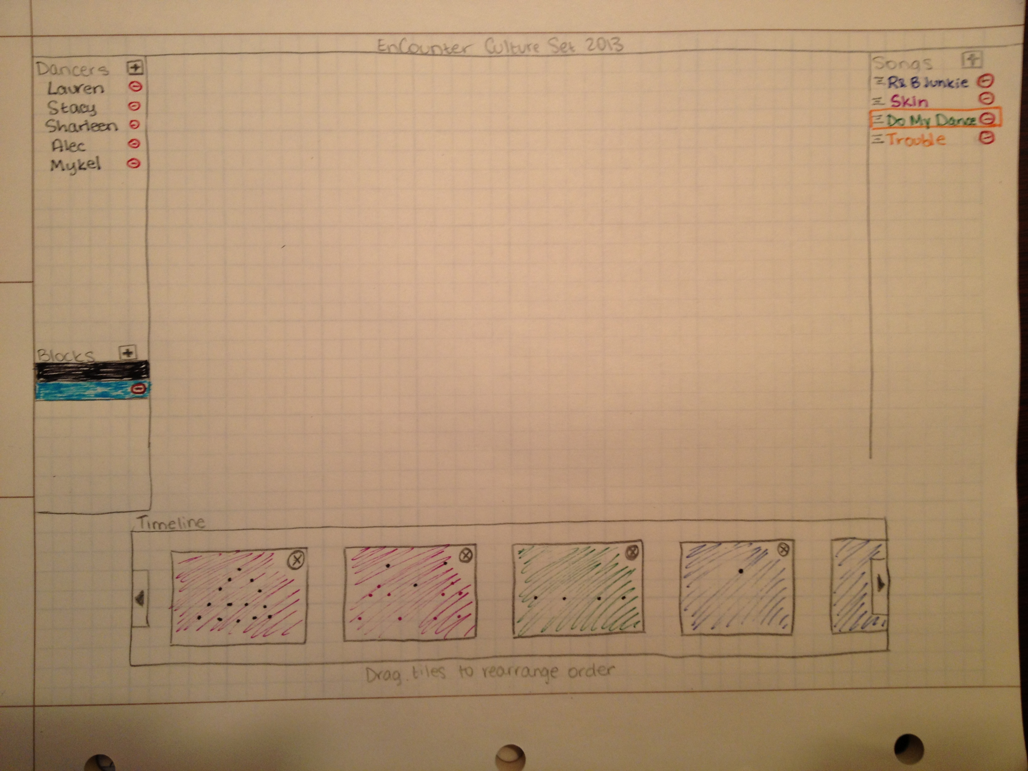

This screen shows the edit options for each feature. You can add/delete dancers. For blocks, you can add/delete colors except for the default (in this case black). The default is necessary because if a block is deleted that had dancers in it, then those dancers are automatically set to default. For songs, you can add, delete, and rearrange the order of songs. Within the timeline, you can delete formations and rearrange formations within their respective dance.